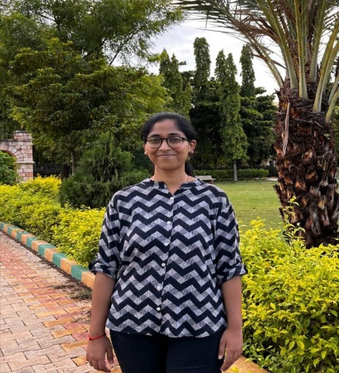**SAKSHI DASHARATH SHINDE**

**Third Year Computer Science**  **Enthusiast sakshi.22210493@viit.ac.in**

# EDUCATION

**Third YEAR Computer Engineering student**

**Vishwakarma Institute of information technology**– Present-Pune ,India

## Secondary (HSC)

**Shardabai pawar mahila mahavidyalay** 2018 – 2020 pune ,India

## 82 (HSC)

**Vatsalabai Gudge kanya prashala mayani**

### 96.30(SSC)

# POSITION OF RESPONSIBILITY

documentation head at VIIT ACM student chapter

# PROFILES

**Hackerrank :** sakshi_[22210493](https://leetcode.com/u/user3980Ha/)

|  |
| --- |
| [**user3980Ha**](https://leetcode.com/u/user3980Ha/) |

**Leetcode:**

**GFG:** sakshi22r4yy

**Github:** [**Sakshishind123**](https://github.com/Sakshishind123)

## TECHNICAL SKILLS

**Programming languages :** java , basic python

**Frontend Tech :**HTML, CSS, JavaScript ,React JS

**Backend Tech:** SQL, Flask

# PROJECT

**Portal for farmer to sell the product at better rate :** CSS, HTML ,JS, FLASK, SQL

**Book inventory System:** C++ ,

**Student management system:** python

## ACHIEVEMENTS

* 3 Solving Star Rating On Hacker rank For Problem in java
* Patent on Automatic pet feeder

## COURSEWORK

* Data Structure and Algorithms
* Object Oriented Programming
* DataBase Management System
* Operating System

## STRENGTHS

Management skills

Dedicated

Team-Work

Learning attitude